**To start the minikube:**

* **Minikube start - -kubernetes-version=”v1.7.0”**
* **Kubectl get nodes**
* **Kubectl get pods**

We can use minikube UI also with **minikube dashboard** command

* **ip:30000**

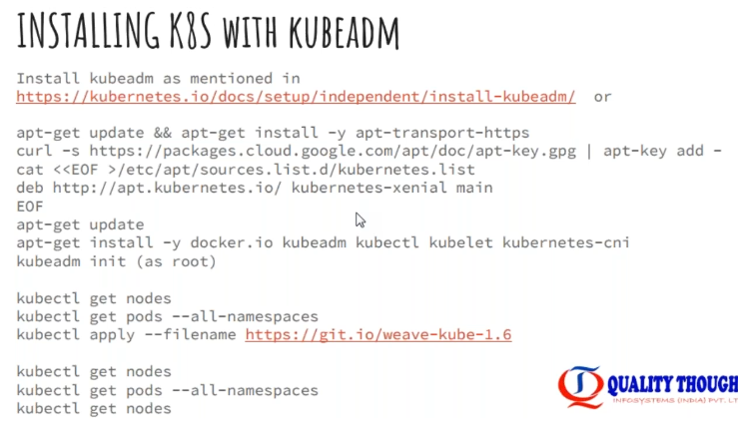

* Kops is popularly used to install kubernetes. There are many third-party installations for easy install of kubernetes

**Installation:**



* We have to install kubectl, kube admin and docker on all the 3 machines
* We do only kubeadm on master machine. Rest of the things we won’t do

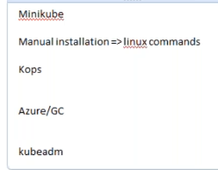

* Minikube is never used in production. It is only to check whether everything is working or not. It is for DEV environment
* Then manual installation is very difficult
* In aws, we have KOPS to install and we don’t need any installation on azure & google cloud. Kubernetes is just a service in those clouds
* Kubeadm used for local, dev & test environments and production is on azure
* We need at least 2 GB RAM on master

**Kubeadm installation**

* Instead of opening the required ports, we can give all traffic to the instance

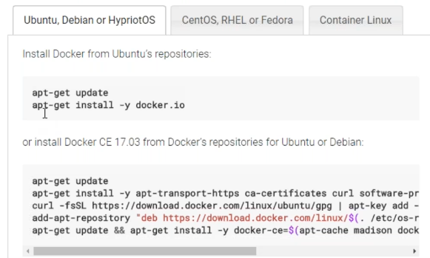

* First, we need to install docker
* Then need to install all below three

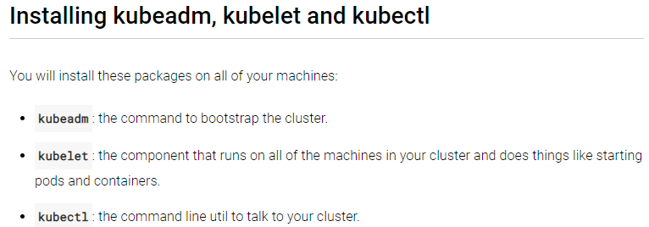

* Connect to root user and run the below commands

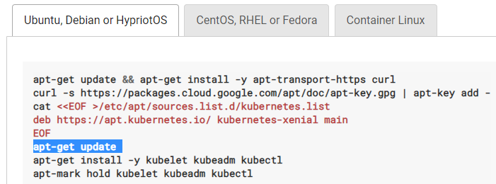

* Once we have installed this, we can have kube admin, kubelet and kube control manager
* That’s all the installation, now we need to configure cluster
* Now run, **kubeadm init** command
* After init command, we need to copy the kubeadm command from the output of init command
* **Kubeadm token list** 🡪 to check the list of token details
* Now go back to the other user and run the below commands to use the kubeadm from non-root user

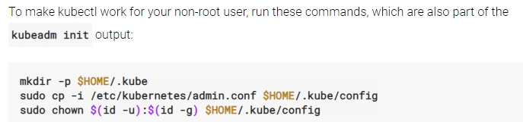

* Now we need to install pod proxy

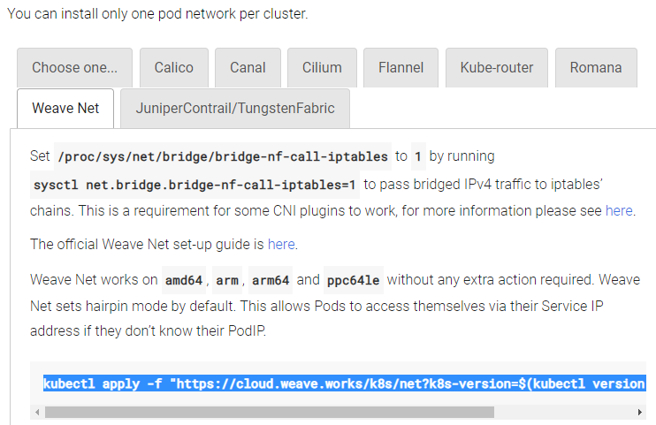

* **Kubectl get pods**
* **Kubectl get pods –all-namespaces**
* If we are getting output for kubectl get pods, then we are good to go
* Now, we need to join our nodes, the nodes also need kubeadm installed in this
* We need to install docker on node also
* For that, just follow the same steps to install on node with root user

Now we need to run the below command on node which we copied from the output on kubectl init command on master

* **kubeadm join 172.31.43.124:6443 --token rc6oqz.ckztr9bfunmcz12s --discovery-token-ca-cert-hash sha256:35ade685786bacde71d9347d60adb5944891c6cdbb1b45927651c9d4d8ba2e1a**

now check whether the node is added from master using below commands

* **kubectl get nodes**
* If we want to add any more nodes, then also we need to follow the same steps
* now the complete installation is done. Now we need to create pods and configure all the things
* that is the main work of us